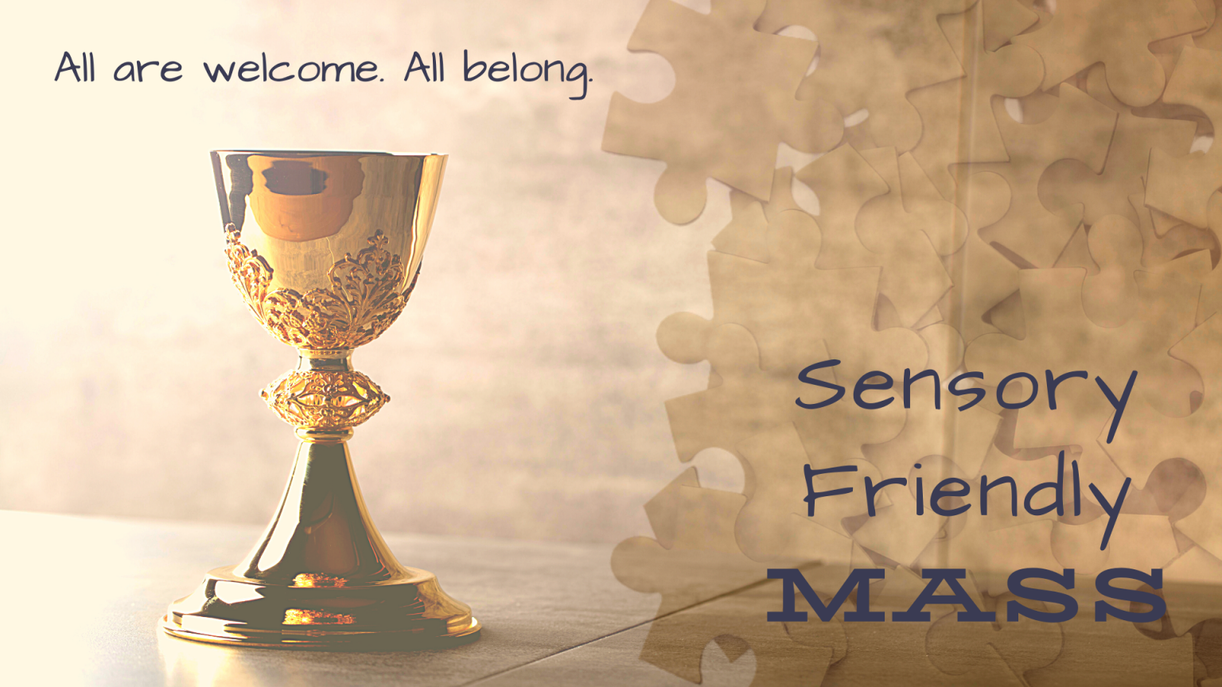

**Sensory Friendly Mass**

**Sunday , September 8**

**12:45 pm**

**St. Pius X Catholic Church**

**7200 Sarto Dr., Indianapolis**

**Reception immediately following in conference rooms**

**In an effort to embrace and welcome the members of our church with Autism, Down Syndrome, other intellectual and developmental disabilities,the elderly or anyone with sensory issues, we will host a Sensory-Friendly Mass. This mass will include accommodations such as lower lights, a shorter more literal homily, use of the Children’s Lectionary and availability of picture schedules.**

**All are welcome to join us!**

**With questions, please contact Shannon Farrell, 317-446-5507**