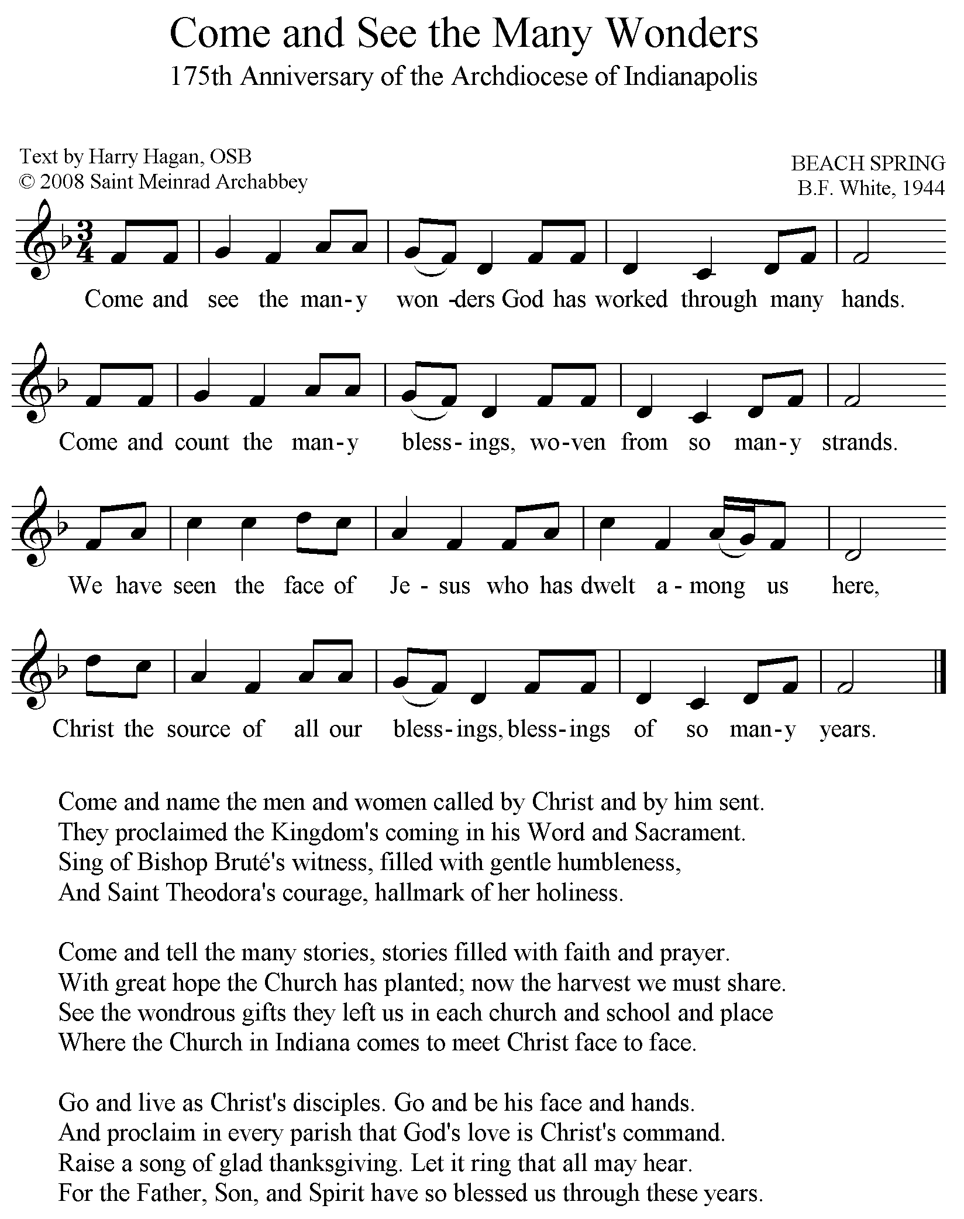

This hymn may be reprinted and used by parishes and institutions of the Archdiocese of Indianapolis for the 175th anniversary year.
The title and subtitle may be reset, but the author and copyright information must be printed as given.

“Come and See the Many Wonders,” was written by Fr. Harry Hagan, OSB, a monk of Saint Meinrad Archabbey, for the celebration of the 175th Anniversary of the Archdiocese of Indianapolis. It may be reprinted and used by parishes and institutions in the archdiocese. The title and subtitle may be reset, but the author and copyright information must be printed as given.

Each of the hymn’s stanzas captures various aspects of the theme of the jubilee: “We Have Seen the Lord; Come and See.” Simon Bruté was the first bishop of the diocese of Vincennes which became the Diocese of Indianapolis in 1898, and Saint Theodora is the formal name for Mother Theodore Guerin who founded the community of the Sisters of Providence at St. Mary of the Woods near Terre Haute in 1840.

Since the text is set to the commonly used tune, BEACH SPRING, accompaniments may be found in most hymnals and song books that use this tune with other hymns such as “God of Day and God of Darkness,” or “Lord, Whose Love in Humble Service.” The hymn may also be sung to any other tune with the metric pattern, 8787D, such as HYFRYDOL (“Alleluia, Sing to Jesus”) or HYMN TO JOY (“Joyful, Joyful, We Adore Thee”).

To preserve good legibility, the size of the hymn should not be further reduced. Its 5.5 inch-wide staves are designed to fit easily on either an 8.5 or 7 inch-wide sheet or page.
A graphic version may be downloaded at…

